SACRE RE Long term plan 2023-2024
RE | AU1 | AU2 | SP1 | SP2 | SU1 | SU2
Nursery | Name of unit  -Make connections between the features of their family and other families.  -Notice differences between people.  Vocabulary: Vocabulary: family, mum, dad, brother, sister, same, different  Key Knowledge:  *Can point to or name the people who live in my house  *Can say if two different families look the ‘same’ or ‘different’  *Can name some physical features that look the same or different | Name of unit  Continue to develop positive attitudes about the differences between people (Diwali/Christmas)  Vocabulary: celebration, Diwali, Christmas, same, different  Key Knowledge:  *Can talk about/name key customs in the Diwali celebration e.g. praying, family meal, fireworks, presents etc..  *Can talk about/name key customs in the Diwali celebration e.g. praying, family meal, presents etc..  *Can say if their celebration is the same or different  Festivals to cover  Harvest: Sharing - How do we share things?  Diwali: What is Diwali? Diwali artwork  Christmas: Nativity- role play | Name of unit  Continue to develop positive attitudes about the differences between people (Chinese New Year)  Vocabulary: celebration, Chinese New Year, same, different  Key Knowledge:  *Can talk about/name key customs in the Chinese New Year celebration e.g. praying, family meal, fireworks, presents etc..  *Can say if their celebration is the same or different  Festivals to cover  Easter– Decorate an egg. | Name of unit  Continue to develop positive attitudes about the differences between people (EID)  Vocabulary: celebration, Eid, same, different  Key Knowledge:  *Can talk about/name key customs in the Eid celebration e.g. praying, family meal, presents etc..  *Can say if their celebration is the same or different  Festivals to cover  Vaisakhi– Bhangra dancing  Eid: Islamic Art
Reception |  | Name of unit  *Know and understand that people believe and live differently  *Explore features of celebrations, festivals and special times  Vocabulary:  Different/similar, beliefs, celebrate, special times, festivals, Diwali, Hindu, Christian, Christmas, Jesus, Eid, Muslim, nativity  Key Knowledge:  *Can name the special times they celebrate  *Can talk about how they celebrate special times  *Know that people with different beliefs have different festivals and celebrations  *Know how to show respect for festivals and special times that are important to others  *Through stories, know why Christians perform nativity plays at Christmas  *Know that harvest is a time where we thank God for food  Festivals to cover (1 lesson for each one)  Harvest: Know What Harvest is  Diwali: Know what Diwali is  Christmas: Know the Nativity story  CHRISTMAS SHOW | Name of unit  -Know some similarities and differences between different religious and cultural communities in this country (Chinese New Year, Visakh, Easter)  Vocabulary:  Different/similar, beliefs, special times, festival, celebration, Sikh, Visakhi, Easter, Jesus, Christian, Chinese New Year  Key Knowledge:  *Know that people with different beliefs have different festivals and celebrations  *Know about the Chinese New Year  *Know about Visakhi (Sikh celebration)  *Know why the cross is important at Easter  *Know that Jesus is a role model for Christians  -Understand that some places are special to members of their community.  Vocabulary:  Home, worship, church, mosque, mandir, gurdwara  Key Knowledge:  *Know some places that are special to them  *Know that some people worship in a special place  *Know the name of their place of worship  *Know the names of some different places of worship  Festivals to cover  Easter: The Easter story- Order the key events.  Vaisakhi : What is Vaisakhi? Share the story of Vaisakhi and look at the 5Ks – articles of Sikh faith  Eid: Islamic Art
Year 1 | Name of unit  Where do I belong? What do I believe?  Vocabulary: belonging, believe, pray, meditate,  Key knowledge:  *Know what matters to them and other people and share their ideas  *Know how to express their feelings of belonging and depending on others  *Know that different people belong to different religions/groups  *Have an awareness of the influence of religion on their community  *Know the important events which occur in families and communities e.g. births, weddings, naming ceremonies  Festivals to cover (1 lesson for each one)  AU1- Harvest: Know how to thank God and others.  AU2- Diwali: Know how people prepare for Diwali.  Christmas: Know happened when Jesus was born. Know how to celebrate new babies? |  | Name of unit  Who is a Christian and what do they believe?  Vocabulary: Bible, Christians, church, community, special times, God  Key knowledge:  *Know some of the ways in which people pray and meditate, e.g. going to church, praying & music  *Know some of the Christian festivals, e.g. Christmas, Easter – stories and symbols  *Know some links between Christian festivals and festivals in other religions  *Know symbols aid worship, e.g. cross, statues, candles, water  *Know that the bible is a sacred text for Christians and that it is used as a life guide, e.g. texts about how Christians should live and treat each other  Festivals to cover (1 lesson for each one)  Easter: Know how Jesus entered Jerusalem and how he was he welcomed. Compare to a modern celebrity or parades.  Vaisakhi: Know what is Vaisakhi?  Eid: Know what happens in a Muslim household at Eid |  | Name of unit  What makes some places special?  Vocabulary: worship, believers, symbolism, ritual objects, gestures  Key knowledge:  *Know that there are some special places where people go to worship and their importance to believers  *Know the different ways in which religious people use and explain symbolism of food, clothing, ritual objects and behaviour
Year 2 | Name of unit  Who celebrates what and why?  Vocabulary: nativity, Diwali, Christmas, Ramadan, fasting, celebrations, Rama and Sita  Key knowledge:  *Know about religious celebrations:  - Know the story of the Nativity and why Christians celebrate this at Christmas  - Know the story of Rama and Sita and why Diwali is celebrated  - Know the importance of Ramadan for Muslims and why Muslims fast  *Know some simple links between festivals in different religions  Festivals to cover (1 lesson for each one)  Harvest: Know various Harvest poetry.  Diwali: Know how the characters Rama and Sita felt in the story of Diwali  Christmas: know how the angels visited Mary. Explore prediction of Jesus’ birth and feelings. |  | Name of unit  What can stories teach us about life?  Vocabulary: believers, sacred text, God, respect, opinions, fairness, sensitive, traditions, religious stories  Key knowledge:  *Know how sacred texts are treated  *Know some religious stories  *Know some questions they have about themselves, life in general and God in particular  *Know how to value and respect own opinions and those of others  Festivals to cover (1 lesson for each one) (Spring 2)  Lent: Know what is Lent?  Easter: Know the symbolism of Easter  Vaisakhi: Know how the Panj Pyare (5 beloved ones) were brave? Make links to personal experiences of being brave  Eid: Know how you could help people who don’t have enough to eat? (Charity links) |  | Name of unit  Who is a Muslim and what do they believe?  Vocabulary: Quran, prophet Muhammed, Allah, 5 pillars of Islam, pray, worship, mosque, dome, minaret, prayer mats, qiblah, mihrab, Ramadan, Eid-Ul–Fitr, Eid-AL-Adha  Key knowledge:  *Know some of the Muslim festivals, e.g. Ramadan, Eid-Ul–Fitr, Eid-AL-Adha  *Know that Allah is the creator and provider of all good things  *Know about the prophet Muhammed – stories about his life  *Know about the 5 pillars of Islam  *Know the use of significant objects, e.g. prayer beads, prayer mats and Quran  *Know that the Quran is a life guide for Muslims  *Know that Muslims have a ceremony to celebrate the birth of a baby – aqiqah ceremony and understand the rituals that come with this.
Year 3 | Name of unit  How is new life welcomed into the new world?  Vocabulary: baptism/dedication, new life, religious symbols, rituals, birth ceremony  Key knowledge:  *Know similarities and differences between different religious belonging ceremonies:  - know what happens at a traditional Christian infant baptism/dedication and suggest what the actions and symbols mean  -Know the rituals of a birth ceremony from two religions other than Christianity and suggest what the actions and symbols mean  *Know religious vocabulary to describe what happens in a ritual of belonging and know why it is important for young people from that religion  Festivals to cover (1 lesson for each one)  Harvest: Know the parable of the good seed  Diwali: Know who is your light.  Christmas: know the significance of the Wise Men visiting Jesus and giving special gifts. |  | Name of unit  Who inspires me?  Vocabulary: leader, inspiring, inspirational, admire, hero, role model, qualities, characteristics  Key knowledge:  *Know stories about an inspirational person explaining why their lives might be considered inspirational  *Know some events in the life of at least one modern day Christian making the link between their actions and the example of Jesus  *Know the qualities that they admire in their heroes/role models  *Know a contemporary inspiring figure, e.g. a local hero, a sporting leader or a person with an outstanding story of courage  *Know why some people choose to stand up for their beliefs in difficult circumstances  Festivals to cover (1 lesson for each one)  Lent: Know what happens on Shrove Tuesday /pancake day.  Easter: Know what the Last supper is and its significance  Vaishaki: Know how the Panj Pyare were baptised and what this meant - links to Christian baptism  Eid: Know how Ramadan and Eid-al-Fitr link to the 5 pillars of Islam  Easter Assembly |  | Name of unit  How does a Christian follow Jesus?  Vocabulary: Trinity, Bible, Lord’s prayer, 10 commandments, baptism  Key knowledge:  *Know that God is the Father, the Son and the Holy Spirit- concept of Trinity  * Know the key features of Jesus’ life and what Christians believe about Christians  * Know that there is diversity within Christianity – different churches, different styles of worship eg Anglican, Baptist and Evangelical  * Understand the significance of prayer and how Christians pray eg Lord’s prayer, through silence and language in worship  * Know that the Bible includes stories, history and poetry and its purpose as a life guide for Christians- 10 commandments
Year 4 | Name of unit: What does it mean to be a Hindu?  Vocabulary: puja, aarti, Hindus, Hinduism, Aum. reincarnation. Mandir, River Ganges, Varanasi, Diwali, Holi, Navratri, Dussehra  Key knowledge:  *Know the Hindu beliefs about the Trimurti, Brahma (creator), Vishnu (preserver) and Shiva (destroyer)  * Know the rituals that Hindus hold at home, eg puja, aarti and personal deities  * Know that Hindus believe in reincarnation  * Know and demonstrate understanding of the symbols in a mandir and why they are important eg puja tray, water, bell incense, food, Aum, swastika, lingam, Nandi and Ganesh  * Know the rules of a visiting a mandir- removing shoes and washing hands  * Know how the key scriptures are used in communities and homes eg Vedas. Bhagavad Gita, Ramayana  *Know the festivals that Hindu’s celebrate, e.g. Diwali, Holi, Navratri, Dussehra  Festivals to cover (1 lesson for each one)  Harvest: Know the importance of charity and why it is important to share what we have with others- Stone soup story or Feeding of the 5000  Diwali: How how light conquers darkness according to Hindus  Christmas: Know how to compare different Christian sects and the ways they celebrate Christmas. |  | Name of unit: What does light mean? What does dark mean?  Vocabulary: light, dark, Diwali, Hannukah, Prophet, Quran, Jesus, story, poetry, art, feelings, experiences  Key knowledge:  *Know ideas about good and evil, truth and error in various religions  - Diwali  -Know the meaning of the story Hannukah for Jewish people – What do the light and dark symbolise in this story?  -Know that for Muslims, light is seen as the holy Quran and the Prophet  - Know the significance of light in Christianity and Jesus as the light of the world and what this means to Christians, e.g. portrayal of Jesus through art  *Know when people need help to guide and light their way – where does this light and guidance come from?  Festivals to cover (1 lesson for each one)  Lent: Know that Lent is a period for reflection and saying sorry. Explore why is it good to say sorry?  Easter: Know that Jesus is a servant king. What does the monarch do on Maundy Thursday?  Vaisakhi: Know how Vaisakhi celebrated through Processions/flag washing  Eid: Know and discuss if alll people should be allowed a day off for their religious festivals  Easter Assembly |  | Name of unit: The journey of life: what is so special about marriage?  Vocabulary: journey of life, marriage Bar/Bat Mitzvah, Amrit, baptism, sacred, responsibility, ceremonies  Key knowledge:  *Know the similarities and differences between 2 religious marriage ceremonies:  - Jewish marriage - Ketubah  - Hindu / Sikhism marriage – meaning of 7 steps  *Know the promises made in marriage and the meaning of these promises  *Know the difficulties and joys of being in a long-term relationship with someone and how people support each other in hard times  *Know how some people with and without a faith want a religious wedding
Year 5 | Name of unit  Why do some people think God exists?  Vocabulary: theist, atheist, agnostic, creation, beliefs, existence,  Key knowledge:  *Know what the terms theist, atheist and agnostic mean  *Understand why an atheist may not believe in God  *Know reasons for why people do or do not believe in God- considering factors such as family background, religious experiences, sense of suffering  Festivals to cover (1 lesson for each one)  Harvest: Know and discuss if it is still worth celebrating Harvest if we aren’t farmers.  Diwali: Know what Diwali is for Sikhs and how this is celebrated.  Christmas: Know and discuss if Christmas is for Christians or for all of us? |  | Name of unit  Justice and poverty: can religions help to build to build a fair world and make poverty history? (Links to Geog. Unit)  Vocabulary: Christian tithing, income, Zakah, fair, unfair, justice, values, kindness, hatred, charitable, in need, annually, poverty  Key knowledge:  *Know what is fair and unfair within your own experiences  *Know some stories and teachings from Christianity which ensure justice and fairness for all people:  - know the teachings of Jesus and Paul on values and justice and their meanings for Christians today, e.g. Widow’s Mite (Mark 12:41-44) and The Rich Fool (Luke 12:16-21)  - Islam: Muhammed overcomes hatred with kindness  - Sikhism: Malak Bhago and Guru Nanak  *Know charitable practices that are part of religious practice:  - Christian tithing, giving 10% of income  - Muslims, Zakah, annually giving away 2.5% of all wealth  - Jewish, giving away 10% of their net income  *Know some of the problems of poverty in the world today and some ways that charities respond to this |  | Name of unit  What does it mean to be a Muslim?  Vocabulary: mosque, Muslims, Shahadah belief Allah Salah prayer Zakat charity Sawm fasting Hajj, dome, prayer mats, minaret, qiblah, mihrab, worship  Prophet, Qur’an, day of judgment, Shi’a, Sunni  Key knowledge:  *Know that Muslims believe in Tawhid (Oness of Allah), Iman (faith), Ibadah (worship/belief)  *Know that Allah guided Muslims through messengers including Muhammad, Jesus, Moses and sacred texts  *Know that Muslims believe in the day of judgement and what this entails  *Know the attributes of Allah in the Quran and the signs of Allah’s creation through nature, human beings as the best of Allah’s creation  *Know the purpose of visual symbols and objects in a mosque, e.g. dome, prayer mats, minaret, qiblah, mihrab – how they aid worship  *Know how Muslim communities in Leicester celebrate festivals  Festivals to cover (1 lesson for each one)  Lent: Know and understand if fasting make you a better person? (link to fasting in other religions)  Easter: Know how Judas betrays Jesus  Vaisakhi: Know how people’s thoughts and feelings change throughout the Vaisakhi events  EID Assembly
Year 6 | Name of unit  What does it mean to be a Sikh?  Vocabulary: Khlasa, Gurdwara, 5 Ks, Guru Nanak, Guru Gobind Singh, Langar, Sikh, Nishan Sahib, Khanda  Key knowledge:  *Know the key beliefs in Sikhism:  - one God  - Sewa – service  - human equality and dignity  *Know the importance of the 10 gurus:  - Guru Nanak’s calling to preach  - the forming of the Khalsa under Guru Gobind Singh  - the collecting together of the first Sikh scriptures  *Know the importance of the sacred text – Guru Granth Sahib for Sikhs:  - how it is understood as a living Guru  -How it is used, treated and learnt from  *Know the importance of the Sikh community:  -The Khlasa  -Wearing of the 5 Ks  -worship in the gurdwata  -eating together in the Langar  -serving others  *Know the beliefs, practices and values that are significant in your lives and compare this to the Sikh community life  Festivals to cover (1 lesson for each one)  Diwali: Know how to compare symbolism of light in Diwali to other religions  Christmas: Know why Christmas is celebrated on 25th December. Link to pre-Christian festivals e.g. Winter solstice & Saturnalia |  | Name of unit:  What matters most to Humanists and to Christians?  Vocabulary: Humanist, Christian, sacrifice, selfish, clash, dilemma, rank, forgiveness, values  Key knowledge:  *Know who is a Humanist and how a humanist and a Christian might have some similar/different values  *Know how and why some people live lives of self-sacrifice and kindness to others, but some are selfish, and many are a mixture of both  *Know the links between values held by you, by Christians and Humanists  *Know that values can clash and dilemmas about doing the right thing can be difficult  *Know what behaviour goes with a value like forgiveness, truth-telling or kindness to animals  Festivals to cover (1 lesson for each one)  Easter: know what is resurrection. Explore if love is stronger than death.  Vaisakhi: Know the tests of faith which Sikhs have endured. Know how Guru Gobind Singh test his followers’ faith?  Eid: Know why self-discipline is important |  | Name of unit  What can we learn from religions about temptations and finding your way through the moral maze?  Vocabulary: temptations, Duni Chand, commandments, Hadith, Beatitudes, beliefs, values, guides, choices, decisions, moral choices, intentions, peer pressure  Key knowledge:  *Know stories from different religions that give examples of how to live a good life:  -e.g. Sikh stories about money Duni Chand and the needle  -the Muslim Hadith or stories about the beauty of creation  -Christian teaching from Jesus on the Beatitudes  *Know the importance of beliefs or values as guides for making choices and decisions in daily life  *Know the differences between right and wrong/good and bad and how we know the difference  *Know what guides your own moral choices  *Know why key religious figures are regarded as sources of authority and inspiration by believers today  *Know what guides your own moral choices:  -know why we often have good intentions but do not always follow them through (work on temptation, bad choices and peer pressure)
SEND – Adaptive Teaching | - Adjust the level of challenge- Provide sentence stems, question prompts to support discussions. Children work in groups to share ideas and work collaboratively. Opportunities for in-depth discussions where children can share and compare their opinions in a respectful manner.  - Targeted support from a TA- provide a list of key questions/vocabulary/visual images for the TA to support with delivery of content. TA has a clear view of the curriculum intent and the lesson objectives prior to the lesson.  - Clarify/simplify a task or provide numbered steps with visual representations (objects, pictures, signs, photos)  - Provide worked (completed) and partially completed examples.  - Highlight essential content- Prioritise key knowledge that children need to learn to secure progression onto next stage.  - Re-explain a concept or explain it in a different way- provide key knowledge through visual aids, auditory methods as well as short, succinct written texts. Educational visits will support this as lead figures of various faiths can share their views and beliefs  - Give additional (or revisit) examples  - Use peer tutoring/collaborative learning (everyone must participate – give them roles)- have opportunities for in depth discussions where children can share their opinions in a safe and respectable space and feel their opinion is valued.  - Provide additional scaffolds- pre teach specific vocabulary, provide sentence stems from oracy talk tactics to initiate rich dialogue, chunk learning into smaller chunks and break learning down into key knowledge  - Set clear targets/expectations  - Provide prompts/sentence stems- provide children with question prompts to support with thinking and reduce cognitive overload and provide/develop with children steps to success for children to work from, provide sentence stems from oracy talk tactics to initiate rich dialogue  - Improve accessibility (e.g. proximity to speaker, visibility of whiteboard, read a text to the pupil)- share information in various ways to meet the needs of all the learners, provide slides from the PowerPoint on tables to make it easier for pupils to see the text on the board etc. Ensure texts that are used are child friendly, use videos that are child friendly  - Consider pace - (extra time for responses to questions, contributing to class discussions and to complete activities) Putting timers on the board so children understand how long they have to complete a task  - Provide vocabulary with visual images- explicitly teach vocabulary at the beginning of a unit alongside a picture or diagram of the key word, use photographs to represent the word when using it during the unit. Practice where pupils say aloud the words. Revisit and recap words during the lesson and through low stake quizzes  - Check understanding and reinforcing as needed through repetition, rephrasing, explaining and demonstration- e.g., use of mini-plenaries to check understanding (quick quizzes), questioning and partner talk.  - Have alternative ways to record learning, e.g. oral, photographic, video, highlighting text, mind maps, etc- take videos of children’s discussions, create QR codes to record learning, mind maps ideas as a group, work is evidenced in the scrapbooks as well as individual books.  - Pre-teach vocabulary, key content etc- Pre-teach key vocabulary using picture or diagrams.
Strategies to stretch and challenge | - Identify and account for prior knowledge – Ensure prior assessments are done at the start of each unit to determine the planning of a unit and how to adapt teaching to push on those who already have a solid understanding. A child who has extensive prior knowledge could be asked to present some of the knowledge they have to the class; explain something they understand easily to a child who doesn’t ‘get it’ so quickly- e.g., peer modelling, a more able child could present facts that they already know to the children, more able children given more challenging enquiry based questions to extend their learning.  - Build on interests to extend - read widely around a subject outside of lesson time by providing them with information about suitable material, e.g. give them suitable higher-level texts to read eg provide in depth questions to explore at home, research extra information related to their unit out of school and share this with the class  - Depth of content - consider what you can add to create depth, e.g. digging into an area more deeply, going laterally with a concept, or asking pupils to use more complex terminology to describe abstract ideas, ask children to share their opinions and compare this with the views of others  - Use questioning techniques to boost thinking – ask open-ended questions which require higher-order thinking eg How, Why? Can you expand? Explain, What if? Have alternative scenarios for children to discuss and debate  - Consider learner roles – ensure they are appropriately challenged through the role they are given so they can make an effective contribution; argue in favour of a viewpoint that is different to their own, e.g. argue the opposite position to that which they actually hold, during a class debate, ensuring this is all done in a respectful manner  - Mastery - more intensive teaching, tutoring, peer-assisted learning, small group discussions, or additional homework  - Differentiated success criteria/choice of task – offer a choice of tasks with a different level of challenge, ensuring there are opportunities for in depth discussions where various conflicting views can be shared and discussed in manner that is respectful  - Feedback – framing feedback so pupils must take responsibility for improving their own learning – pupils can also self evaluate and peer evaluate during discussions using the oracy framework
Harvest
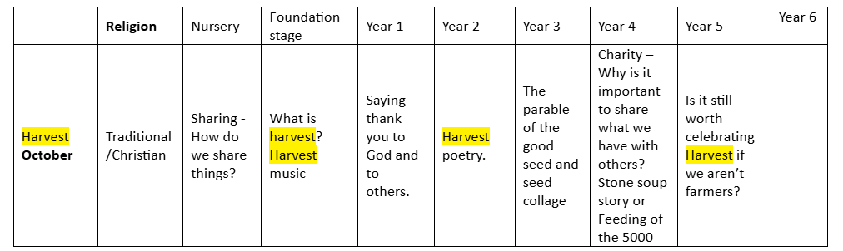
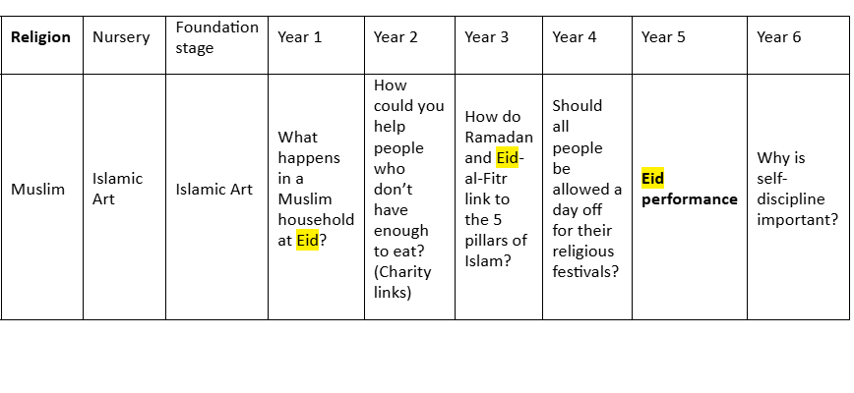
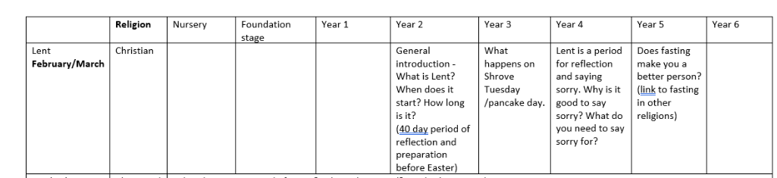
 | Religion | Nursery | Foundation Stage | Year 1 | Year 2 | Year 3 | Year 4 | Year 5 | Year 6
Diwali  October/November | Hinduism/ Sikhism | What is Diwali?  Diwali artwork | Know what Diwali is | Know how people prepare for Diwali. | Know how the characters Rama and Sita felt in the story of Diwali | Know who is your light. | How how light conquers darkness according to Hindus | Know what Diwali is for Sikhs and how this is celebrated. | Know how to compare symbolism of light in Diwali to other religions

