
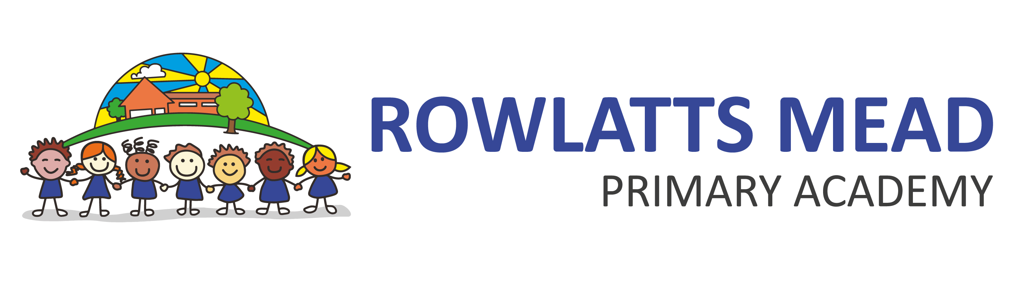

SPECIAL EDUCATIONAL NEEDS POLICY

Policy Monitoring, Evaluation and Review

Version: | 1.2
Date created: | September 2020
Author: | - Pirbhai
Ratified by: | LAC
Date ratified: | September 2022
Review date: | September 2023

Revision History:

Version | Date | Author | Summary of Changes:
1.0 | September 2020 | D. Swann | Policy update
1.1 | September 2021 | D. Swann | Policy update
1.2 | September 2022 | - Pirbhai | Policy Update

Aims and Objectives of this Policy

Mission Statement

Together we succeed through challenge and enjoyment

Rowlatts Mead Primary Academy is committed to providing a secure, stimulating, personalised and inclusive environment.

Children will develop high self-esteem, independence, and respect for others and acquire skills to become life-long learners and celebrate cultural diversity.

Inclusion statement

We endeavour to make every effort to achieve maximum inclusion of all pupils whilst meeting pupils’ individual needs.
The aims of the SEN policy and practice in this school are:
- To reach high levels of achievement for all
- To be an inclusive school
- To meet individual needs through a wide range of provision
- To attain high levels of satisfaction and participation from pupils, parent and carers
- To share a common vision with all stakeholders
- To provide curriculum access for all
- To work towards inclusion in partnership with other agencies and schools
- To achieve a level of staff expertise to meet pupil need

Partnership with Parents/Carers

The school aims to work in partnership with parents and carers. We do so by:
- Working effectively with all other agencies supporting children and their parents
- Giving parents and carers opportunities to play an active and valued role in their child’s education
- Making parents and carers feel welcome
- Encouraging parents and carers to inform school of any difficulties they perceive their child may be having or other needs the child may have which need addressing
- Instilling confidence that the school will listen and act appropriately
- Focusing on the child’s strength as well as areas of additional needs
- Allowing parents and carers opportunities to discuss ways in which they and the school can help their child with the additional support of annual reviews and Pupil Outcome Plans (POP)
- Agreeing targets for the children in reviews and Pastoral Support Plans (PSP) review meetings
- Keeping parents and carers informed and giving support during assessment and any related decision-making process about SEN provision
- Making parents and carers aware of SENDIASS (previously Parent Partnership). This information is available to all parents in the foyer and from the SENCO
- Providing all information in an accessible way

Involvement of Pupils

We recognise that all pupils have the right to be involved in making decisions and exercising choice (SEN Code of Practice). All pupils are involved in monitoring and reviewing their progress. We endeavour to fully involve all, pupils by encouraging them to:

- State their views about their education and learning
- Identify their own needs and learn about learning
- Share in individual target setting across the curriculum
- Self-review their progress and help to set new targets

In addition pupils who are identified as having SEN are, if appropriate, invited to participate in:

- POP and PSP reviews and setting of POP and PSP targets
- Regular meetings with named adults
- Annual reviews
- Involvement of pupil’s opinions through questionnaires

Management of SEN within School

The Academy Councillors have delegated the responsibility for the day to day implementation of the policy to the D Swann (Principal) and A Pirbhai (SENCo). All staff in the academy have a responsibility for pupils with SEN. All teachers are teachers of special education needs. Staff are aware of their responsibilities towards pupils with SEN, whether or not pupils have an Education and Health Care Plan. A positive and sensitive attitude is shown towards those pupils. Staff responsibilities are identified in individual job descriptions.

Teaching assistants play a major role in the support of pupils with SEN. The rationale for the deployment of TAs is pupil centred.
The SENCO is responsible for:
- Overseeing the day-day operation of this policy
- Co-ordinating provision for children with special educational needs
- Liaising with and advising teachers
- Managing teaching assistants
- Overseeing the records of all children with SEN
- Liaising with parents of children with SEN (in conjunction with class teachers and TA’s)

The SENCO is responsible for reporting to the governor with responsibility for SEN on the day-day management of SEN policy. The name of the academy councillor with responsibility for SEN is Cathy Hannon. Regular meetings take place termly and more frequently if required.

Admission Arrangements

No pupil will be refused admission to school on the basis of his or her special educational need. In line with the SEN and Disability Act we will not discriminate against disable children and we will take all reasonable steps to provide effective educational provision in line with the LA policy

Identification and Assessment

We accept the principle that pupils’ needs should be identified and met as early as possible. The SENCO and the Leadership Team use whole school data as an early identification indicator. Whole school data is also used to monitor and evaluate the progress of pupils identified as having SEN and discussed at year group progress meetings.

The Engagement Model is used to monitor the progress of pupils achieving significantly below age related expectations.
The school adopts the levels of intervention as described in the SEN Code of Practice. Appendix A3 of the LA document Meeting Individual Needs is used as a point of reference. We use a number of additional indicators of special educational needs.
- The analysis of data including entry profiles, Foundation Stage Profile, SATs, reading ages, annual pupil assessments
- The pupil in context profile (MIN document appendix A2)
- Following up parental concerns
- Pupil self-referral
- Tracking individual pupil progress over time
- Liaison with feeder school on transfer
- Information from previous schools
- Information from other services
The SENCO maintains a register of pupils identified through the procedure listed. This register is reviewed termly. A detailed analysis of the register takes place termly. For some pupils a more in-depth individual assessment may be undertaken by the school in consultation with outside agencies. Any advice given by the external agency is communicated to all adults working with the pupil, and their parents/carers.
The protocols and procedures described in Meeting Individual Needs are used for maintaining paperwork and conducting reviews at all levels of intervention including pupils with statements of special education needs.

We aim for a smooth transition between classes, phases and schools for all pupils and ensure that records are maintained and transferred efficiently.

Statutory assessment will use the pre-key stage standards to record attainment.

Curriculum Access and Provision

In order to meet the learning needs of all pupils, teachers differentiate work. They work to meeting individual learning needs and to mark work and plan homework effectively. Where pupils are identified as having special educational needs, the school provides for these additional needs in a variety of ways. The provision for pupils is related specifically to their needs. A provision map identifies possible interventions and this maps these against individual (or group) pupil need.

The range of provision includes:
- In class support for small groups with TA
- Small group withdrawal with teacher or TA support
- Individual class support/individual withdrawal
- Further differentiation of resources
- Peer support
All pupils who have additional support at school will be on a Provision Map. Those that receive agency support will have a Pupil Outcome Plan (POP). For pupils with an EHCP, provision will meet the recommendations on the statement. In subjects where all children have curriculum targets these are used to inform POPs.

Links with Education Support Services

Effective working links are maintained with:
- Educational Psychology Service (EPS)
- Special needs Teaching Service (SNTS)
- Special Education Service (SES)
- Educational Welfare Service
- Speech and Language Service
- Behaviour Support –Pri SEMH
- TMET Primary Intervention Team
- Early Years Support
The SENCO will maintain links with other SENCOs through the TMET SENCO network.

Links with Other Services

Effective working links are maintained with:
- Other Children and Young People’s Services
- Community Health Service
- Family Support and Safeguarding (including RALAC and Social Care and Health)
- SENDIASS
INSET

In order to maintain and develop the quality of our provision, staff are encouraged to undertake training. Performance management reviews and staff appraisals support the identification of areas for development. Input from external agencies is actively encouraged.

SEN procedures and practice in school are discussed with all new staff. All staff receive induction on taking up a post. Teachers receive ongoing support from their year group partner. All staff receive ongoing support from SENCO.

Resources

The provision for SEN is funded by both the delegated budget, standards fund and central funding. Funds are deployed to implement the SEN policy. The following principles have been identified to support this: Staff are deployed to support children with EHCPs, POPs, behaviour needs and at additional school action. There is also an allocation for resource and training.

Complaints

If there are any complaints relating to the provision for pupils with SEN these will be dealt with in the first instance by the Principal. The Chair of the Academy Council may be involved if necessary. In the case of an unresolved complaint the LA may be involved.

Monitoring and Evaluation

We set targets for monitoring and evaluating the effectiveness of the SEN policy. The actions to meet these targets are identified in the SEN action plan.

Equality

This policy should be read alongside the academy’s Single Equality Policy, Racial Equality Policy and Equal Opportunities Policy.





EHCP
For children with more complex needs
EHCP
For children with more complex needs

High quality teaching plus extra short-term support

For children making slower progress

SEN Support
Additional long-term, individualised support
For children with identified needs and agency involvement

Quality First Teaching for all pupils

High quality, differentiated teaching – for all children

Levels of support at Rowlatts Mead Primary Academy 2021-2022

