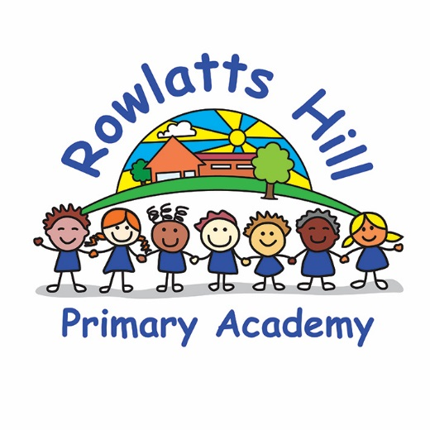

Geography Policy

Rowlatts Mead Primary Academy Geography Policy

Statement

This policy outlines the teaching, organisation and management of the Geography taught and learnt at Rowlatts Mead Primary Academy. The implementation of this policy is the responsibility of all the teaching staff.

Aims and Objectives

Through the teaching of geography we aim to:
- Stimulate pupils' enthusiasm for, and curiosity about their surroundings and the wider world.

- Increase their knowledge and understanding of the different communities and cultures within Rowlatts Hill, Leicester, Britain and the world - and how these relate to each other.

- Increase their knowledge and understanding of the changing world

- Make sense of their own surroundings through learning about their own locality and the interaction between people and the environment.

- Develop the geographical skills, including how to use, draw and interpret maps of different scales, and the vocabulary necessary to carry out effective geographical fieldwork and enquiry.

- Apply map reading skills to globes and atlas maps and identify geographical features.

- Formulate appropriate questions, develop research skills and evaluate material to inform opinions.

- Enable children to work geographically in a range of appropriate contexts, using a variety of materials and equipment including other people’s experiences and knowledge.

Planning

- Geography is to be taught across the curriculum through specific topics over the course of the year. At Rowlatts Mead Academy, we plan using the National Curriculum (December 2014) statements. Foundation Stage will follow the new statutory framework for EYFS (September 2021) and Geography will be taught through Understanding the World.
- Progression of Skills and Geography Sequencing Documents should be followed to support planning and teaching.
- A diverse range of teaching styles and resources should be used to maximise pupil’s learning.
- Enrichment opportunities linked to Topics and curriculum statements should be planned to enhance pupil’s learning where possible.

Monitoring and Assessment

Assessment by the class teacher will involve questioning, observation, discussion, group work and written work. Differentiation through support and outcomes will guide teacher judgement. Target Tracker statements should also be used to assess pupil’s progress. Outcomes of both formal and informal assessment strategies should be use to identify groups or individuals and it should be used to inform future planning.

Termly book scrutinies and learning walks will allow Geography Lead to ensure Curriculum documents are being followed and statements are being met. Geography Lead will also support teachers and monitor progress across the school via planning meetings, subject leader masterclasses and regular discussions.

Equal Opportunities

Access to the curriculum should be ensured for every child regardless of age, disability, gender, sexual orientation, nationality, race, religion or socio-economic background by:

- Creating effective learning environments in which stereotypical views are challenged and pupils learn to appreciate and view positively difference in others.
- Ensuring all forms of bullying and harassment, including racial harassment, are challenged and dealt with appropriately.
- The provision of up to date resources without stereotypical bias.
- The provision of differentiated activities and experiences to enhance and support the learning of all children.
- Encouraging all children to answer questions and take part in discussions by creating an atmosphere in which they feel secure.
- The provision of good role models by all the adults they encounter in school.

Policy updated – September 2021 – Rima Modhwadia

