


Special Educational Needs Policy

Policy Monitoring, Evaluation and Review

Version: | 1.3
Date created: | September 2020
Author: | Sophie Tales and A. Pirbhai
Ratified by: | Board of Trustees
Date ratified: | September 2022
Review date: | September 2023

Revision History:

Version | Date | Author | Summary of Changes:
1.0 | September 2020 | D. Swann | Policy update
1.1 | September 2021 | D. Swann | Policy update
1.2 | September 2022 | A. Pirbhai | Policy Update
1.3 | June 2023 | S. Tales and A. Pirbhai | Graduated Response to SEND added, updated processes, included SEND flow chart

Rationale

This policy is a statement of the arrangements of Inclusion at Rowlatts Mead Primary Academy. It has been written to make these explicit and to ensure continuity of practice across the school. It has been written in response to the Equality Act 2010: advice for schools DfE Feb 2013, SEND Code of Practice 0-25 Sept 14 and Statutory Guidance on supporting pupils at school with medical conditions April 2014. We believe that to be fully inclusive we need to be aware of and cater for children, parents and staff who have a whole range of needs including Special Educational Needs and Disabilities.

At Rowlatts Mead Primary Academy, we provide education for all pupils through a variety of strategies including, appropriate differentiation, resources and facilities as necessary. All pupils’ individual needs are considered and we implement a range of strategies to meet and develop their diversity. We believe that all children should be equally valued in school. We will strive to eliminate prejudice and discrimination, and to develop an environment where all children can flourish and feel safe. This does not mean that we will treat all learners in the same way, but that we will respond to learners in ways which take account of their varied life experiences and needs.

We believe that educational inclusion is about equal opportunities for all learners, whatever their age, gender, ethnicity, impairment, attainment and background. We pay particular attention to the provision for and the achievement of different groups of learners. All pupils are entitled to receive, within a suitable peer group, a broad balanced and relevant curriculum. The school will, within the context of services and resources available, seek the relevant support and advice from the LA, in order to facilitate inclusion. At Rowlatts Mead Primary Academy, we aim to identify these needs as they arise and provide teaching and learning contexts which enable every child to achieve their full potential.

Aims:

We endeavour to make every effort to achieve maximum inclusion of all pupils whilst meeting pupils’ individual needs.
The aims of the SEND policy and practice in this school are:
- To be an inclusive school by meeting individual needs through a wide range of provision
- To share a common vision with all stakeholders
- To deliver a curriculum that is accessible for all
- To work in partnership with other agencies and schools to support individual needs.
- To reach high levels of achievement for all by developing staff knowledge and understanding of all pupils needs.

The Academy Councillors have delegated the responsibility for the day to day implementation of the policy to J. Henson (Principal) and A. Pirbhai (SENDCo). All staff in the academy have a responsibility for pupils with SEND. All teachers are teachers of special education needs. Staff are aware of their responsibilities towards pupils with SEND, whether or not pupils have an Education and Health Care Plan.

Rowlatts Graduated Response to SEND

The SEND Graduated Response guidance is intended to be used as a tool for schools and settings and those partner agencies working with them and has been created in collaboration with SEND professionals, parents and carers and young people.
The guidance has been designed to help ensure children and young people across the County with Special Educational Needs reach their full potential. It sets out Local Authority expectations for the ways in which all schools and settings should meet the needs of children and young people with SEND.
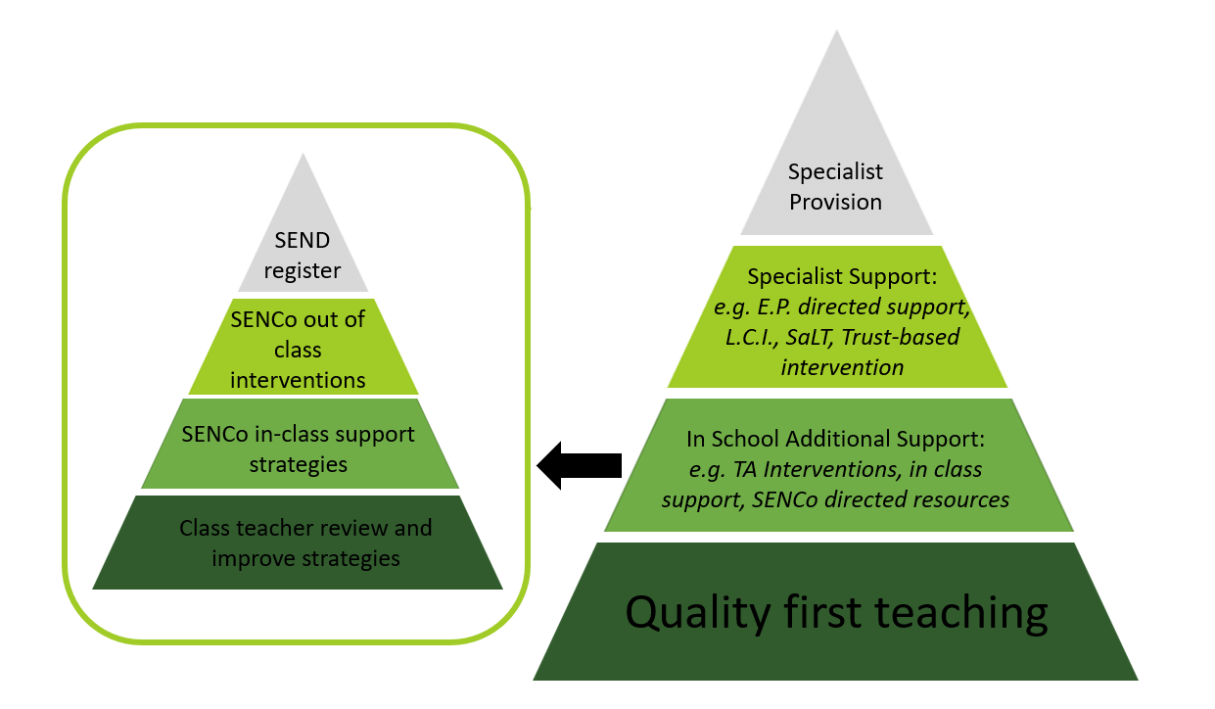

The SENDCo is responsible for:

- Overseeing the day to day operation of the SEND policy
- Co-ordinating provision for children with special educational needs
- Liaising with and advising teachers
- Managing Learning Support Assistants
- Overseeing the records of all children with SEND
- Liaising with external agencies as well as parents of children with SEND (in conjunction with class teachers and LSAs)
- Ensuring that SEND training is delivered to all staff.

The SENDCO is responsible for reporting to the Academy Councillors with responsibility for SEND on the day to day management of SEND policy. The name of the academy councillor with responsibility for SEND is Deborah Swann. Regular meetings take place termly and more frequently if required.

Partnership with Parents/Carers

The school works in partnership with parents and carers. By:

- Communicating and liaising between agencies and parents/carers
- Holding meetings with parents to discuss their child’s education (annual reviews, Pupil Outcome Plans etc)
- Encouraging parents and carers to inform school of any difficulties they perceive their child is having
- Keeping parents and carers informed and giving support during assessment and any related decision-making process about SEN provision
- Making parents and carers aware of SENDIASS. This information is available to all parents in the foyer and from the SENDCo

Involvement of Pupils

We recognise that all pupils have the right to be involved in making decisions and exercising choice (SEND Code of Practice). All pupils are involved in monitoring and reviewing their progress. We endeavour to fully involve all pupils by encouraging them to:

- State their views about their education and learning
- Identify their own needs and learn about learning
- Share in individual target setting across the curriculum
- Self-review their progress and help to set new targets

In addition, pupils who are identified as having SEND are, if appropriate, invited to participate in:

- POP reviews and target setting of POP
- Regular meetings with named adults
- Annual reviews
- Involvement of pupil’s opinions through questionnaires

Admission Arrangements

No pupil will be refused admission to school on the basis of his or her special educational need. In line with the SEND and Disability Act we will not discriminate against disabled children and we will take all reasonable steps to provide effective educational provision in line with the trust inclusion policy

Identification, Curriculum and Assessment

We accept the principle that pupils’ needs should be identified and met as early as possible. The SENDCo and the Leadership Team use whole school data as an early identification indicator. Whole school data is also used to monitor and evaluate the progress of pupils identified as having SEND and discussed at year group progress meetings.

The Engagement Model is used to monitor the progress of pupils achieving significantly below age related expectations.
The school adopts the levels of intervention as described in the SEND Code of Practice. Appendix A3 of the LA document Meeting Individual Needs is used as a point of reference. We use a number of additional indicators of special educational needs.
- The analysis of data including entry profiles, Foundation Stage Profile, SATs, reading ages, annual pupil assessments
- The pupil in context profile (MIN document appendix A2)
- Following up parental concerns
- Teacher referral to SENDCo
- Pupil self-referral
- Tracking individual pupil progress over time
- Liaison with feeder school on transfer
- Information from previous schools
- Information from other services

The SENDCo maintains a register of pupils identified through the procedure listed. This register is reviewed termly. A detailed analysis of the register takes place termly. For some pupils a more in-depth individual assessment may be undertaken by the school in consultation with outside agencies. Any advice given by the external agency is communicated to all adults working with the pupil, and their parents/carers.
The protocols and procedures described in Meeting Individual Needs are used for maintaining paperwork and conducting reviews at all levels of intervention including pupils with diagnosed SEND. See Appendix A for additional information on identification and assessment.

Curriculum Access and Provision

In order to meet the learning needs of all pupils, teachers adapt their teaching. Where pupils are identified as having special educational needs, the school follows the graduated approach (as indicated in the SEND code of practice).

The range of provision includes:
- In class support for small groups with LSAs
- Small group withdrawal with teacher or LSA support
- Individual class support/individual withdrawal
- Further adaptation of resources
- Peer support

All pupils who have additional support at school will be on a Provision Map. Those that receive agency support will have a Pupil Outcome Plan (POP). For pupils with an EHCP, provision will meet the recommendations on the statement. In subjects where all children have curriculum targets these are used to inform POPs.

Interventions are reviewed termly. Children are placed on interventions which are suited to their learning need. These are run by teachers or LSAs.

Links with Education Support Services

Effective working links are maintained with:
- Educational Psychology Service (EPS)
- Special needs Teaching Service (SNTS)
- Special Education Service (SES)
- Educational Welfare Service
- Speech and Language Service
- Behaviour Support –Pri SEMH
- TMET Primary Intervention Team
- Early Years Support
- Mental Health Support Team (MHST)

Links with Other Services

Effective working links are maintained with:
- Other Children and Young People’s Services
- Community Health Service
- Family Support and Safeguarding (including RALAC and Social Care and Health)
- SENDIASS

The SENDCO will maintain links with other SENDCOs through the TMET SENDCO network.

Resources

The provision for SEND is funded by both the delegated budget, standards fund and central funding. Funds are deployed to implement the SEND policy. The following principles have been identified to support this: Staff are deployed to support children with EHCPs, POPs, behaviour needs and at additional school action. There is also an allocation for resource and training.

Complaints

If there are any complaints relating to the provision for pupils with SEN these will be dealt with in the first instance by the Principal. The Chair of the Academy Council may be involved if necessary. In the case of an unresolved complaint the LA may be involved.

Monitoring and Evaluation

The Mead Educational Trust as well as Rowlatts Mead Primary Academy sets targets for monitoring and evaluating the effectiveness of the SEND policy. The actions to meet these targets are identified in the SEND action plan in conjunction with the School Improvement Plan.

Equality

This policy should be read alongside the academy’s Single Equality Policy, Racial Equality Policy and Equal Opportunities Policy.

Appendix A
