


Anti-bullying Policy

Policy Monitoring, Evaluation and Review

Version: | 1.0
Date created: | May 2023
Author: | S Tales
Ratified by: | Board of Trustees
Date ratified: | June 2023
Review date: | June 2025

Revision History:

Version | Date | Author | Summary of Changes:
1.0 | May 2023 | STA | TMET created Policy

Aims of the Policy

At Rowlatts Mead Primary Academy we are committed to providing a caring, friendly and safe environment for all pupils so they can learn in a relaxed and secure atmosphere. Bullying of any kind is unacceptable at our school. If bullying does happen, all pupils should be able to tell someone and know that incidents will be dealt with quickly and effectively. We are a TELLING school. This means that anyone who knows that bullying is happening is expected to tell the staff. No one deserves to be a victim of bullying and should be treated with respect. We believe that all children have the right to come to school without fear of being bullied. Everybody has the right to be treated with respect. Pupils who are bullying need to learn different ways of behaving. We have a responsibility to respond quickly and effectively to issues of bullying.

- All academy councillors and teaching and non-teaching staff know what the school policy is on bullying, and follow it when bullying is reported.
- All academy councillors, teachers and non-teaching staff, pupils and parents have an understanding of what bullying is.
- All pupils and parents should know what the school policy is on bullying, and what they should do if bullying arises. As a school we take bullying seriously. Pupils and parents should be assured that they will be supported when bullying is reported. Bullying will not be tolerated.

What is Bullying?

Bullying is repeated behaviour by an individual or group with the intention of hurting another person.
We teach children the definition with STOP:

Several Start
Times Telling
On Other
Purpose People

Bullying can be:

EMOTIONAL Being unfriendly, excluding, teasing (e.g. hiding or throwing equipment) or threatening PHYSICAL Pushing, kicking, hitting, punching or any use of violence
RACIST Racial taunts, graffiti, gestures
SEXUAL Unwanted physical contact
HOMOPHOBIC Name-calling or insults VERBAL Name-calling, sarcasm, spreading rumours, teasing CYBER-BULLYING Text messages, email, social networking, apps and video games

Equality Act 2010

At Rowlatts Mead Primary Academy, we regularly discuss and support all aspects of the Equality Act (2010). Discussions take place both through assemblies and our curriculum, at an age-appropriate level, to help our children build a growing awareness of the principles and impact of the Equality Act (2010). Children are encouraged to recognise how our similarities and differences unite us and enrich the local, national, and global communities that we belong to.

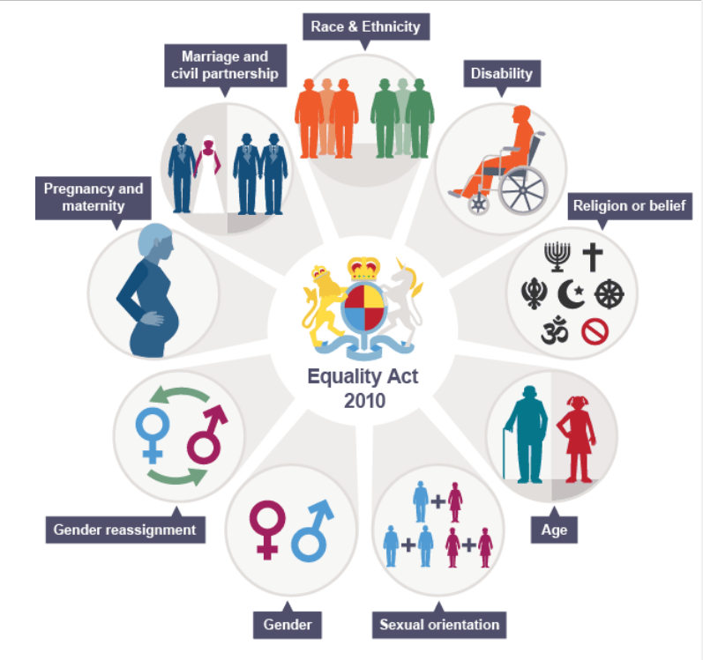
Strategies:

A culture of telling
Every child has the opportunity to raise any issues in classrooms with their class teacher or teaching assistant. All children’s concerns will be addressed before the end of a school day. Children also undertake weekly PSHCE and morning time activities where class issues can be discussed and addressed. All complaints of bullying will be taken seriously and an investigation will take place, first by the class teacher and then, if appropriate, by a senior leader.

Peer support systems
There are playground buddies in the junior playground, and lunchtimes helpers in the infant playground at lunch. If they see concerning behaviour they are encouraged to approach an adult with their concerns.
These will be taken seriously and followed up.

Groups and clubs
At the start of the school day, staff, including senior leaders, great children at the school entrances as well as the classroom doors to provide plenty of opportunity for carers and children to discuss any concerns they may have. Clubs and groups are arranges for break, lunch and after school to support positive interactions with peers in smaller group settings, away from the business of the main playground.

Reporting and monitoring
If a bullying issue is reported, class teachers will complete an initial investigation into the situation. This
will be followed up by a senior leader if it has happened STOP (several times on purpose). If the incident reported is the first time, teachers will make a record of this in case it arises again. Senior leaders adopt many strategies of how they deal with bullying and this will be specific to the case. Parents of both the child accused of bullying and the victim are informed.

Anti-bullying week
We support the national Anti-Bullying Week initiative that aims to raise awareness of actions that can be
taken against bullying throughout the year. Every child takes part in a range of anti-bullying based
activities in their class. Assemblies are run during this time and throughout the year to maintain
awareness of the issue.

Curriculum
Our PSHCE scheme includes sessions that tackle ways of dealing with bullying or what to do if you have witnessed an incident of bullying. Staff are aware of the sensitive nature of these sessions and establish an approachability that allows children opportunities to talk outside a whole class setting if
appropriate or necessary.

Character Education
We are a school that promotes character, including the character traits that actively promotes friendship
and unity. We explicitly teach and promote teamwork, cooperation and tolerance. This is explicitly taught within Key Stage 1 within the Purposeful Play curriculum whereby each week, as an addition to PSHCE lessons, children complete play-based activities with a focus on developing friendships and character.

Support
- We always put the safety of children first
- Children know who they can report bullying to
- Investigate any allegation of bullying, talking to all children involved separately
- Provide support to the child being bullied – a ‘buddy’ and monitor the situation. All staff will be informed.
- Playground buddies
- Lunchtime clubs
- Key adult allocated
- There will be a record kept of any incidents that occur. Parents of children involved in any incidents will
- be informed. All staff will respond to pupil or parental concerns seriously and support the agreed
- procedures.

If you are dissatisfied with the resolution of a particular incident, then please contact a member of the
senior leadership team.

