
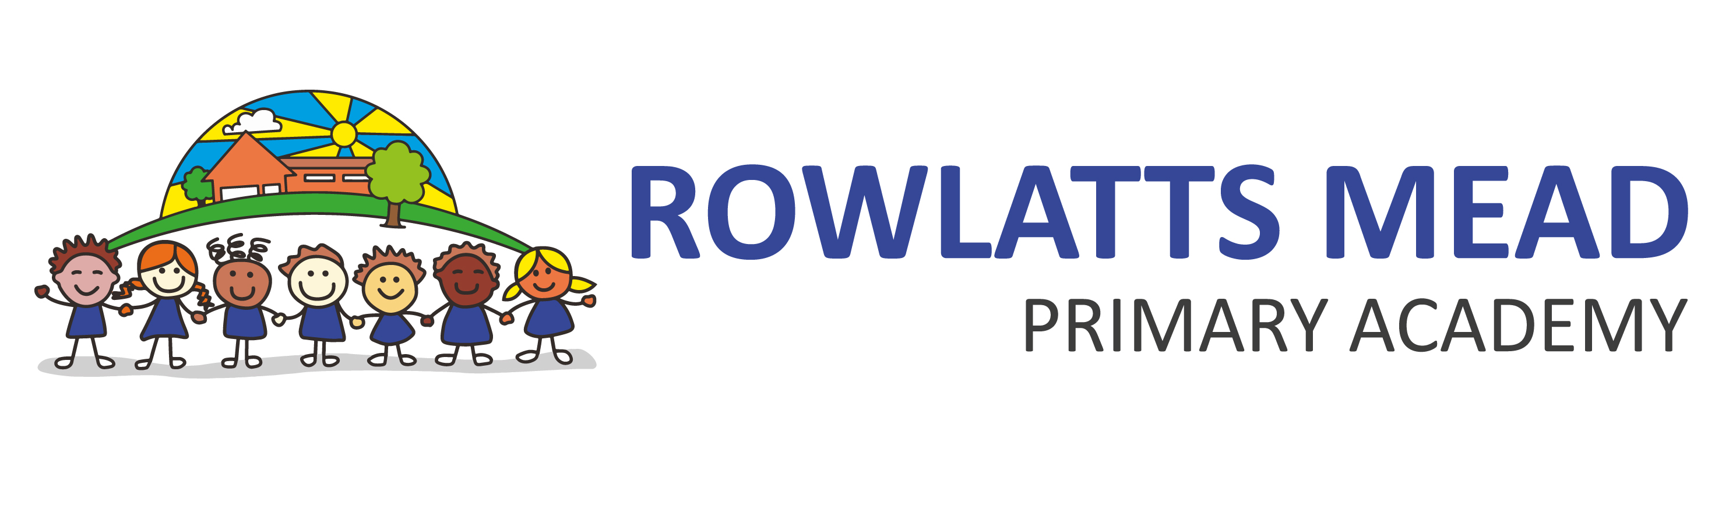

Positive Behaviour Policy

Policy Monitoring, Evaluation and Review

Version: | 1.2
Date created: | September 2021
Author: | D Swann
Ratified by: | Board of Trustees
Date ratified: | June 2023
Review date: | June 2024

Revision History:

Version | Date | Author | Summary of Changes:
1.0 | 25.09.2021 | D Swann | Policy reviewed and updated to new TMET format.
1.1 | 21.09.2022 | A Ashcroft | Policy updated with changes relevant to new documentation.
1.2 | 15.06.2023 | S Tales and W Hussey | Aims of the policy updated along with pupil’s/staff/parent responsibilities, Graduated Response to Behaviour added, House teams added, Purposeful Play added, Rewards amended and updated, Consequences amended and updated, Appendices updated.

Aims of the Policy

- To encourage a positive, calm, purposeful, safe and happy atmosphere within the school
- To maintain an atmosphere free from prejudice and bullying*
- To encourage increasing independence and self-discipline so that each child learns to accept responsibility for their behaviour
- To have a clear and consistent approach to behaviour throughout the school
- To share the rewards for following the academy values
- To set out the sanctions for unacceptable behaviour
- To give children the opportunity to reflect on their behaviour

* Definition - Bullying is a conscious, aggressive and repeated intention to hurt, threaten, frighten or intimidate someone else by an individual or a group, causing pain or distress. This can be in person or take place online.

Pupil’s Responsibilities are:

- To treat people with respect
- To treat people fairly
- To challenge themselves to be the best they can be

Staff Responsibilities are:

- To create a safe and welcoming environment
- To develop positive relationships with all children
- To ensure the academy values are followed
- To raise pupils’ self-esteem and help them develop to their full potential
- To use rewards, rules and sanctions clearly and consistently
- To be a good role model
- To recognise each child as an individual and be aware of their needs, treating them with respect and understanding.

All staff will avoid: | All staff will always:
Humiliating  Shouting  Over-reacting  Over punishment  Jumping to conclusions  Sarcasm  Leaving pupils outside rooms  Holding a grudge | Keep calm and aim to de-escalate the situation  Listen to the child’s perspective  Be positive  Build relationships  Be fair and consistent  Address challenging behaviour  Carry out any consequences that have been issued  Ensure pupils feel accepted

Parents Responsibilities are:

- To treat staff and other parents with respect
- To treat staff and other parents fairly

Graduated Response to Behaviour

Rowlatts Mead Primary Academy uses a Graduated Response to Behaviour management within school. This response ensures that positive behaviour is an active part of all areas of school curriculum and ethos. Children who need additional support with their behaviour, who have shown on repeat occasions to make the same mistakes, will be provided with additional in-school school before specialist support is sought. If behaviours are repeated consistently without in-school support providing the required impact, external specialist support will be sought to ensure that the child’s needs are met.

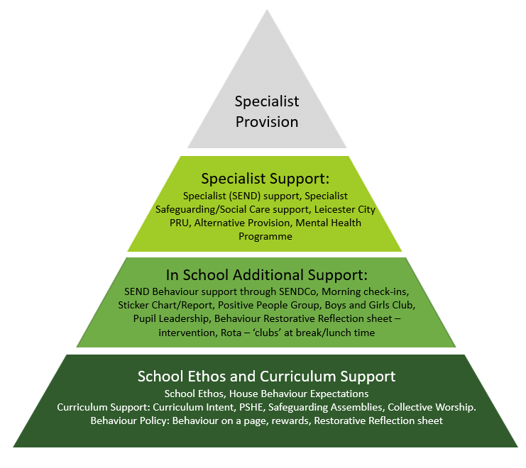
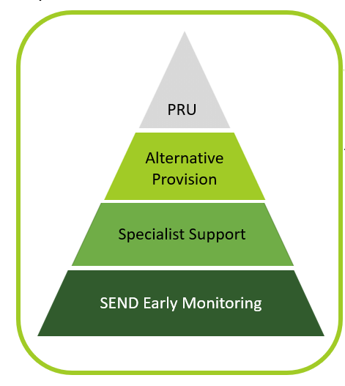
Learning Behaviours

Rowlatts Mead Primary Academy follows the Read, Write Inc. programme for reading development. As part of this scheme, non-verbal hand gestures are used to enable pace of teaching delivery and, therefore, increase learning time. Pupils are trained in these gestures throughout the year.

“When everyone ususes the same routines effectively, behaviour management will be transformed across your school. Children will be in no doubt of the expectations when they move into new groups each half term, and teachers wont waste time in establishing a new set of routines. New staff will then be able to slip into the same routines quickly.” (Read Write Inc., 2016)
 | 1 – Stand up  2 – Stand by your chair  3 – Sit Down/Go to your line
 | Teacher stop sign. Children copy in silence.
   | Talk to your partner
   | No hands up  - Cold call  - Choral response  - Popcorn  - Wave
 | Silent area/Red Zone
   | My turn, your turn
   | Magnet eyes
Purposeful Play

At Rowlatts Mead Primary Academy, we recognise the importance of teaching children how to show respect, treat others fairly and value challenge. Therefore, the Purposeful Play curriculum has been created to support children in Key Stage 1 to learn how to behave appropriately and showcase the school ethos in their interactions with their peers. This curriculum is taught to all Key Stage 1 pupils as part of their weekly subject delivery.

Rewards: Good to be Green!

At Rowlatts Mead, we believe it is good to be green and will reward pupils who consistently follow the school’s vision. All pupils begin each term as ‘green’.

Most pupils will respond to encouragement and rewards and, it is hoped, by promoting positive behaviour and by challenging themselves, pupils will be in a climate of outstanding behaviour for learning.

Staff members can praise in several ways:


- Verbal praise/encouragement
- House Points for your House Team
- Showing work to staff/peers
- Twitter post
- Goodie box
- Community Assembly Certificate
- Party with the Principal
- House Party
- Green Event

House Teams

Rowlatts Mead Primary Academy: Inspiring learners, through respect, equality and challenge.

At Rowlatts Mead Primary Academy, children belong to a House Team. These four Houses represent a connection to the Leicester community through local successful, inclusive and respected sports teams. Through showing respect, equality and challenging themselves, children earn house points for their house team. These house points are added up at the end of each half term and the highest achieving team is rewarded for their dedication to the school’s vision.


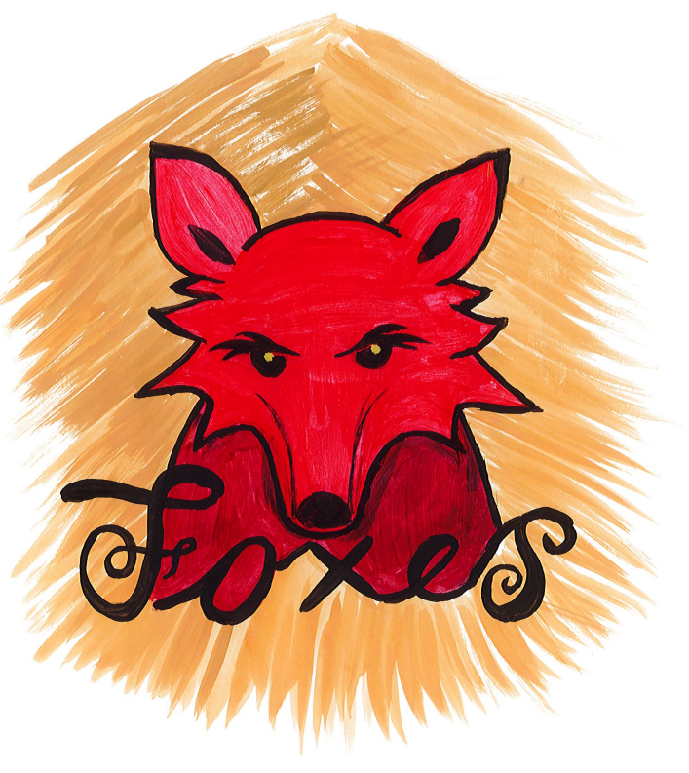
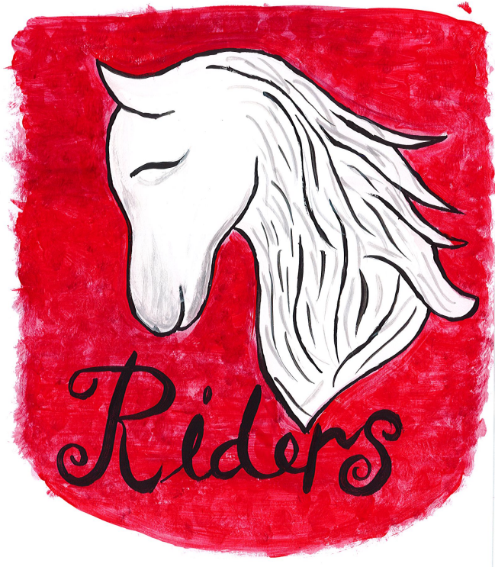

House Points

House points are awarded to pupils throughout the school day for displaying positive behaviour and attitude to learning. House points are tracked by the class teacher through Class Dojo whereby pupils and parents can view their total house points for that academic year. There are specific house point milestones that pupils can work towards to gain specific rewards. House points are reset at the end of each academic year.

100 house points | Goodie box in leadership office
200 house points | House badge
300 house points | Goodie box in leadership office
400 house points | House badge
500 house points | Goodie box in leadership office
600 house points | House badge
700 house points | Goodie box in leadership office
800 house points | Bronze house badge
900 house points | Goodie box in leadership office
1000 house points | Silver house badge
1100 house points | Goodie box in leadership office
1200 house points | Gold house badge

Community Assembly Certificate

Each week, class teachers will choose one child from their class who have been outstanding in modelling Rowlatt’s ethos of respect, equality and challenge. These children will be presented with a certificate in Community Assembly which will be their invitation to Party with the Principal.

Party with the Principal

Party with the Principal will be held in the Principal’s office each week, after Community Assembly where there will be party games and food to enjoy.

House Party

Each half term, the House Team with the highest total of points will be rewarded with a House Party for all House team members. This takes place in the school hall with snacks and party activities to enjoy.

Green Event

Each term, all children who are ‘Green’ will have the opportunity to take part in an afterschool reward. For Key Stage 1 this will be a film screening after school with popcorn and hot chocolate. For Key Stage 2 this will be a sleepover at school including pizzas, snacks and play-time activities.

To be ‘Green’ at Rowlatts Mead you must not get a yellow or red card for behaviour, reading, homework, or attitude to learning as well as have attendance above 95% for that term. See page 8 and 9 for yellow and red behaviours.

Consequences

There is still a need to apply consequences to those pupils who do not meet our standards of behaviour, to modify unacceptable behaviour and to protect the school community. Sanctions must be consistent, fair and carried out immediately. Pupils must be made aware of why the sanction is being carried out. Teachers must log any incidents that require sanctions (STAGE 5 and above) on to the school’s record keeping system CPOMS and alert key holders. Logged incidents are monitored by the principal/managers and reported on in the principal’s report to local academy councillors.
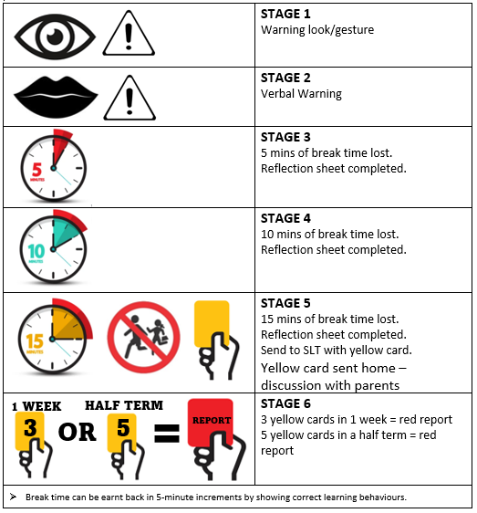

EYFS Adaptations
EYFS will follow the same behaviour systems as the rest of the school, with the below amendments to STAGE 1 and STAGE 2 of the behaviour policy to support children in recognising poor behaviour.
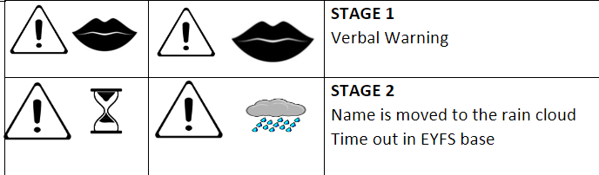
Stage 3 and 4
When a pupil loses 5 or 10 minutes of break time, whilst staying inside at break time, they will also complete a ‘Behaviour Reflection Sheet’ to consider their behaviour and how to rectify it. See appendix 1
Once the break time has been lost and Reflection Sheet has been completed, children return to STAGE 1.
Stage 5
When a pupil loses 15 minutes of break time, they must complete a ‘Behaviour Reflection Sheet’. See appendix 1
On reaching this stage, pupils will be sent to a member of Senior Leadership with a yellow card which will be reviewed by the member of Senior Leadership and sent home. See appendix 2.
Once the break time has been lost and Reflection Sheet has been completed, children return to STAGE 1.
Stage 6
If a pupil receives 3 yellow cards in a week, or 5 in a half term, they will be put on to Red Report. See appendix 3.
Red Report
Pupils who are on Red Report, will spend break and lunch times inside the school to reflect on their behaviour. They will also not be invited to attend after school clubs that week or be invited to Green Day at the end of the term.
Pupils who are on Red Report, will have their report monitored and signed daily by a member of Senior Leadership. In order to complete Red Report, pupils will need to have 20/25 positive learning sessions over the week. See appendix 3.
Pupils who have been unsuccessful in passing their Red Report 2 weeks in a row, will be referred by the class teacher to the SENDCo and be considered for Early Monitoring of a potential SEND need in connection with their behaviour.
Instant Yellow Behaviour

There are a number of behaviours which would result in a child receiving an instant Stage 6. These include:
- Homework - 3rd strike of not completing in a half term.
- Reading – 3rd strike of not completing in a half term.
- Using swear words
- Purposeful unkindness
- Fizzy drinks or sweets

Instant Red Behaviour
There are a number of behaviours which would result in a child receiving an instant Stage 7. These include:
- Physical Aggression
- Homework – 5th strike of not completing in a half term.
- Reading – 5th strike of not completing in a half term.
- Swearing at someone
- Bullying (Several Times On Purpose)
- Refusing to hand in your mobile phone
- Using a mobile phone in school time
- Intentional use of homophobic/racist/sexist language
- Chewing gum or energy drinks
- Stealing
- Vaping or smoking
- Damaging other people’s property
Repeat or Significant Red Behaviour
If a pupil has repeated the same red behaviour on multiple occasions or has shown a significant red behaviour (severe bullying, physical aggression or act against a protected characteristic, for instance) then a meeting will be arranged with the parents/carers and a discussion about next steps will take place.
Next steps may include: Early Monitoring SEND Support, internal exclusion at Rowlatts, internal exclusion at another trust school or a fixed term exclusion at home (recorded officially and shared with the trust and Local Authority).
External, fixed term exclusions will be considered on a case-by-case basis. In extreme circumstances, an immediate exclusion may be issued due to the safety of the child in question or them putting others at risk.

Specific Behaviour Consequences

Mobile phones

Pupils in Years 5 and 6 are permitted to bring mobile devices to school. However, pupils must hand their devices in to their teacher at the start of the day. Devices will be held at the school office until the end of the school day.

Pupils found with mobile devices on their person during the school day will have their mobile device confiscated. Confiscated devices must be collected by parent/carer at the end of the school day.

Certain types of mobile device usage, whether inside or outside of school, can be classified as criminal conduct. The school takes such conduct extremely seriously and will involve the police or other agencies as appropriate. Such conduct includes but is not limited to: sexting; threats of violence or assault and abusive calls, emails, social media posts or texts directed at someone on the basis of someone’s ethnicity, religious beliefs or sexual orientation.

Mobile devices in school are the pupils’ responsibility. The school/Trust accepts no responsibility for mobile phones that are lost, damaged or stolen on school premises or transport, during school visits or trips, or while pupils are travelling to and from school.

Bullying

The values of the school promote kindness. Where pupils report bullying or cyber-bullying the academy will act quickly to support the individuals. Incidents of bullying MUST be reported to the principal or vice principal immediately and staff must follow the guidance set out in the school’s Anti-Bullying Policy.

Guidelines on Intervening in Fights/Disputes

Through the implementation of this policy, we expect fighting to be an extremely rare occurrence. However, if a child does lose his / her temper and becomes involved in a fight it will be taken extremely seriously. If a member of staff witnesses a fight they must remember:
- Our first duty is to prevent harm to any pupil
- To assess the severity of the situation
- Ask other children to move away
- To send a reliable child for additional help if necessary
- Verbally separate the children involved – tell them to stop in an assertive voice
- Standing between the pupils may be appropriate to stop the fight
- It is school policy to intervene and physically prevent a pupil form hurting him / herself or anyone else (see the school’s Positive Handling Policy)
- Quiet discussion away from the scene will follow and the opportunity will be given for pupils to give their side of the story
- We will always listen to children

If a pupil runs out of a class, we will establish where he or she has gone. Teachers will not run after them but will send a message to the office for adult support. It is advisable to keep a watchful eye on any child who has taken him or herself out of the school building and possibly out of school grounds. If a child is no longer on school premises, parents will be contacted. If they are not at home, the police will be informed that a pupil has left school and is at risk.

Discriminative Incidents

Rowlatts Mead Primary Academy takes a zero-tolerance approach to discriminatory behaviour with particular focus on the protected characteristics of race, disability, gender, age, gender reassignment, religion or belief, pregnancy and maternity, marriage and civil partnership and sexual orientation. All incidents are recorded, reported and investigated according to the school’s policy. Any incidents of a discriminatory nature will require an intervention where children are educated on the seriousness of their actions. They will be supported to understand how they can make better choices.

Harmful sexual behaviour and harassment
At Rowlatts Mead there is a zero-tolerance approach to harmful sexual behaviour and sexual harassment. It is never acceptable and it will not be tolerated. It should never be passed off as “banter”; “just having a laugh”; “a part of growing up”; or “boys being boys”.

All staff and pupils are encouraged to call out and/or report this behaviour. If pupils make these comments or behaviour in a manner that is deemed harassing, we will:
- Ask them to apologise
- Seek to understand the behaviour
- Consult Brooks Traffic Light system for advice
- Inform parents of both the victim and perpetrator
- Support and educate them to improve their behaviour
- Monitor their behaviour for any recurrence
- Log it on CPOMS
- Escalate the sanction to the principal if the pupil refuses to apologise or change their behaviour
- Seek advice from other professionals

Any allegations must be reported to a DSL immediately and recorded using CPOMs. An investigation will be carried out and the appropriate sanction will be implemented. Further intervention will then be sought for the children involved. The school may also choose to put in place a risk assessment for individuals following these incidents.

When referring to sexual harassment we mean ‘unwanted conduct of a sexual nature’ that can occur online and offline and both inside and outside of school. When we reference sexual harassment, we do so in the context of child-on-child sexual harassment. Sexual harassment is likely to: violate a child’s dignity, and/or make them feel intimidated, degraded or humiliated and/or create a hostile, offensive or sexualised environment.

Whilst not intended to be an exhaustive list, sexual harassment can include:
- Sexual comments, such as: telling sexual stories, making lewd comments, making sexual remarks about clothes and appearance and calling someone sexualised names;
- Sexual “jokes” or taunting;
- Physical behaviour, such as: deliberately brushing against someone, interfering with someone’s clothes.
- Displaying pictures, photos or drawings of a sexual nature;
- Up-skirting (this is a criminal offence);
- Online sexual harassment.

This may be standalone, or part of a wider pattern of sexual harassment and/or sexual violence. It may include:
- Consensual and non-consensual sharing of nude and semi-nude images and/or videos.
- Sharing of unwanted explicit content;
- Sexualised online bullying;
- Unwanted sexual comments and messages, including, on social media;
- Sexual exploitation; coercion and threats;
- Coercing others into sharing images of themselves or performing acts they’re not comfortable with online

At Rowlatts Mead Primary Academy, we understand it is important that school considers sexual harassment in broad terms. Sexual harassment (as set out above) creates a culture that, if not challenged, can normalise inappropriate behaviours and provide an environment that may lead to sexual violence.

In the case of a child reporting an incident of sexual violence, (sexual violence includes rape, assault by penetration and sexual assault; this may include an online element which facilitates, threatens and/or encourages sexual violence) it is vital the adult’s response is appropriate.

- The child needs to feel they are being listened to and taken seriously
- They must not be made to feel ashamed
- Two adults will need to be present to hear the allegation, one of whom is a Designated Safeguarding Lead
- It is important the children are kept separate
- Both victim and alleged perpetrator need to be heard in a calm and safe space
- The Designated Safeguarding Lead will contact Duty and Assessment and follow advice regarding whether to contact the police following the allegation
- Parents will be informed by the designated safeguarding lead
- Senior leaders will use the Brook Sexual Behaviour Traffic Light Tool when considering Harmful Sexual Behaviour and consider appropriate consequences
- Where appropriate, risk assessments are implemented to safeguard children in cases where behaviour has been viewed to sit outside the green behaviour in the Brook Sexual Behaviour Traffic Light Tool
- Adults will continue to check in with all children involved in the days after an allegation, ensuring they feel safe and secure in school
- All incidents will be reported on CPOMs

For more information see TMET Peer on Peer Abuse Policy v1.0.pdf

Suspension and Exclusion

Suspension or exclusion may be applied to persistent incidents of Stage 6 unacceptable behaviour, an illegal act or compromising the physical safety of those in the school community.

For more information see TMET Suspension and Permanent Exclusion Policy v2.0.pdf

Positive Handling

If a pupil is in a situation whereby they are unsafe or are compromising the safety of others, in line with Department for Education and Leicester City Council Health and Safety guidance, members of staff have the power to use reasonable force. Members of staff are trained in ‘Team-Teach’ which is positive handling training.

For further details, please see the Addendum: TMET Restrictive Physical Intervention Policy which can be found on the TMET website or by following this link.

TMET Restrictive Physical Intervention Policy (addendum to Behaviour Policies).pdf

Appendix 1
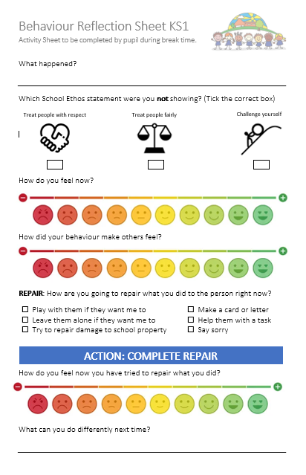

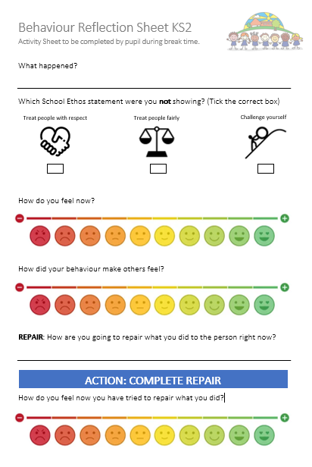
Appendix 2
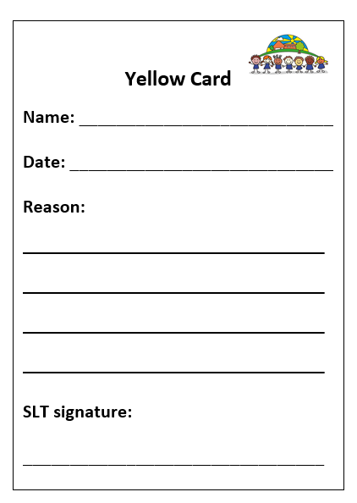

Appendix 3

